Name of the corresponding author:
Email address:
Institution:
Paper research area:
Contributions: | Standard | Original

Abstract Title

N. Surname¹, N. Surname², N. Surname^{1,2}
¹Department, Institution/Company, City, Country
²Department, Institution/Company, City, Country
email address

The abstract must be written in English and its length must be two pages: the first page for text and references (approximately 500 words), the second page for figures and tables. The two-page abstract must synthetically describe the objectives, methods and results of the work.
A sample figure is shown in Fig. 1. If necessary, relevant equations can be included in the abstract.
(1)
Equations and reference citations must be numbered as (1) and [1], respectively. Figures and tables must be placed in the second page.
For the abstract preparation, please respect the following format specifications according to this document template. Page: A4, left, right, top and bottom margins 2,5cm. Title: 22pt, Times New Roman. Authors and affiliations: 11pt, Times New Roman. Text: 12pt, Times New Roman. Space between text paragraphs: 6pt. Captions of Figures and Tables: 10pt Times New Roman. References: 10pt, Times New Roman. Do not number pages.
The abstract submission deadline is June 30th (Thursday), 2022 at 23.59 GMT+1. The notification of acceptance is scheduled on July 15th (Friday), 2022. For any questions feel free to contact the SIE-2022 organizing committee by email sie2022@dimes.unical.it.
When submitting their abstract as a PDF file, through the EasyChair online system, the Authors must select one specific SIE scientific area among those reported in Table 1. Authors can submit their abstracts at the following EasyChair link: https://easychair.org/conferences/?conf=sie20220. Abstract submissions via email cannot be accepted. Eligible abstracts will be accepted either as lecture presentations or as poster.

References

[1] N. Surname et al., “Title of the Paper”, Journal/Transaction Name, vol. xx, n. x, year, pp. Xx-xx.
[2] N. Surname et al., “Title of the Paper”, Proc. of Conference Name or Acronym, year, pp. xx-xx.
[3] N. Surname et al., “Title of the Chapter in a Book”, in Title of the Book, publishing house, year, pp. xx-xx.
[4] N. Surname et al., Title of the Book, publisher, year.

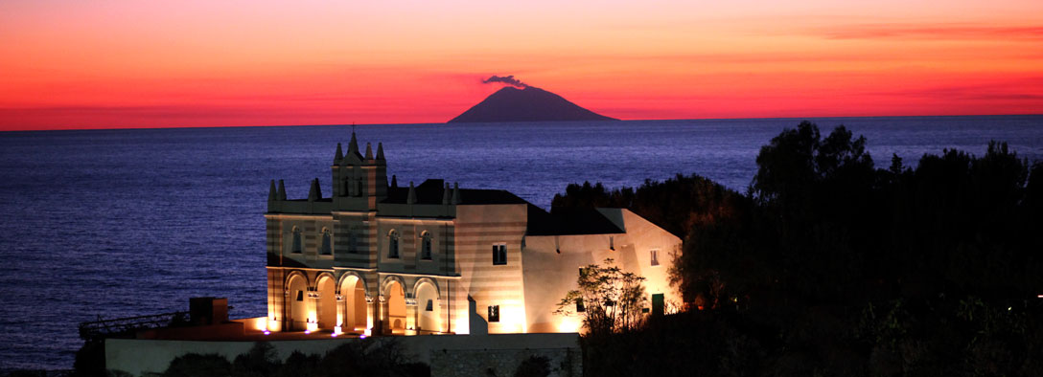
Figure 1: SIE-2022 banner.

Area | Title | Area coordinator
Area 1 | Integrated Circuits and Systems  (Sistemi elettronici integrati) | Prof. Carlo Samori
Area 2 | Micro- and Nano-Electronic Devices  (Dispositivi micro e nano elettronici) | Prof. Fernanda Irrera
Area 3 | Microwave Electronics  (Elettronica delle microonde ed onde millimetriche) | Prof. Giorgio Vannini
Area 4 | Sensors, Microsystems and Instrumentation  (Sensori, microsistemi e strumentazione) | Prof. Giuseppe Ferri
Area 5 | Optoelectronics and Photonics  (Optoelettronica e fotonica) | Prof. Luigi Zeni
Area 6 | Power Electronics  (Elettronica di potenza e applicazioni industriali) | Prof. Giorgio Spiazzi
Area 7 | Electronic Systems and Applications  (Sistemi elettronici e applicazioni) | Prof. Riccardo Berta
Table 1: SIE Scientific Areas

